Curriculum Vitae of  JAMES J. HOLLAND  Trial Lawyer  Hall & Holland  1109 Broadway  Vancouver, WA 98660  Phone: W (360) 694-3351: C (206) 713-1866  Website: www.hallandholland.com  Email: JimJ@HallAndHolland.com | 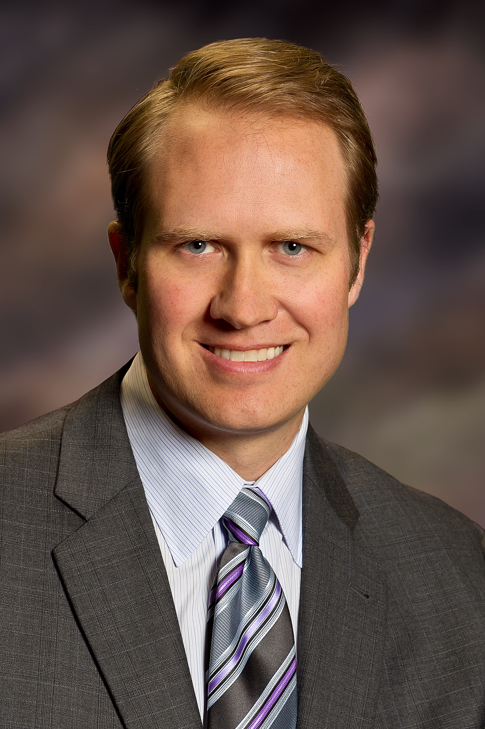

LEGAL EDUCATION: | Doctor of Law (J.D.)  Willamette University College of Law  Salem, Oregon (2002)  Articles Editor, Willamette Law Review
UNDERGRADUATE  EDUCATION: | Bachelor of Arts in Business Administration (B.B.A.)  University of Washington, Seattle, Washington (1999)
PROFESSIONAL  EXPERIENCE: | Law Offices of Hall & Holland  Trial Lawyer, Vancouver, Washington  Perey Law Group, PLLC  Trial Lawyer  Personal Injury and Medical Malpractice Law  Seattle, Washington  The Gosanko Law Firm  Trial Lawyer, Mercer Island, Washington  King County Prosecuting Attorney’s Office  Deputy Prosecuting Attorney, Seattle, Washington  Perkins Coie, LLP  Trial Lawyer, Seattle, Washington  Product liability litigation; emphasis on motions practice, discovery and other pretrial civil litigation.
PROFESSIONAL  ASSOCIATIONS: | Washington State Association for Justice (WSAJ), formerly Washington State Trial Lawyers Association (WSTLA), Continuing Legal Education Committee Member; Chairman, Eastside King County Roundtable, 2011-2012  Wild Steelhead Coalition, VP Legal & Political Affairs, 2010-2011
ADMITTED TO  PRACTICE LAW: | - Washington State Supreme Court and all subordinate courts  - United States District Court for the Western District of Washington
PROFESSIONAL HONORS: | - Rising Star in Washington Law and Politics, 2011, 2012  - National Trial Lawyers Top 40 Under 40 selection, Washington State, 2012  - American Society of Legal Advocates Top 40 Under 40 Litigation lawyers in Washington State, 2014  - Life Member, Multi-Million Dollar Advocates Forum  - Tried more than thirty criminal cases to verdict as a King County Deputy Prosecuting Attorney.  - 2011 jury verdict of more than $500,000 against insurance carrier who offered $10,000 to settle chronic pain claim prior to trial.  - 2012 jury verdict of $479,000 against insurance carrier who offered $10,000 to settle chronic pain claim prior to trial.  - 2013, Rothenberger v. Kent School District, $2,000,000 settlement for student who lost the use of his arm at school from a non-safety glass window.  - 2013, Tressel v. Sagvold, jury verdict of more than $177,000 against defendant who injured 78 year-old client and offered $85,000 to settle claim prior to trial.  - Trial counsel, Johnson v. Lang, $2,400,000 award for the client in real-estate partnership dissolution.  - 2013, co-lead trial counsel, three-week medical malpractice trial.  - Lee v. Duke, $10,000,000 judgment against defendants for wrongful death of 17 year-old girl.  - Lead trial counsel, 16th Street Investors, LLC v. Morrison, 153 Wn.  App. 44, 223 P.3d 513 (2009), prevailing party under real-estate purchase and sale contract.
PUBLICATIONS AND  LECTURES: | Cross-examining the Not-So-Independent CR 35 Examiner, WSAJ Annual Meeting & Convention, July 2014  Never Let a Client Sign a Defense Medical Records Stipulation, WSAJ Trial News, January 2013  Obtaining Verdicts in Excess of Policy Limits, Trial Stars Seminar, Washington State Association for Justice, December 7, 2012  What I Learned in Trial, WSAJ Trial News, December 2013  What I Learned in Trial, WSAJ Trial News, June 2012  What I Learned in Trial, WSAJ Trial News, December 2011  “Taking” Another Look at IOLTA: Applying Loretto’s “Per Se” Test to Government Exactions of Money, 39 Willamette Law Review 101 (2002)  School Sports Can be Hazardous: Settlement with Kent School District for Arm Injury, WSAJ Trial News, June 2013
PERSONAL EXPERIENCES  AND INTERESTS: | - Married to Tiffany Holland and father of two beautiful daughters: Kate and Julia. Owner of a mischievous beagle named Flash.  - Fly-fishing World Record holder: 202.5-pound tarpon, Homosassa, Florida, 2001.  - FAA certified private pilot.  - African safari guide, Zimbabwe, Africa.  - African biological research expedition member, Kenya, Africa.  - Avid outdoorsman and fanatical fly-fisherman.  - Enjoy being a good husband, father, friend and son.  - Enjoy exploring, flying, traveling, skiing, and exercising.

